**Practice Project 3**

**File Handling**

**Sai Krishna Rajagopal**

**03-03-2022**

**GITHUB Repository URL:** [**https://github.com/SaiKrishna6699/CoreJavaTraining.git**](https://github.com/SaiKrishna6699/CoreJavaTraining.git)

**Technical Summary:**

1. **Java**
2. **Eclipse**
3. **Git**
4. **Java:**

The File Handling was developed in Java Programming Language using the concepts of File Handling, Exception Handling, Java IO

* The Application is fully functional and working perfectly with No Exceptions

Short Summary of code:

* + The main class contains the Working of the application.
  + The main method Takes the Commands from the user to Inert, Delete, Update, Search and View Data in the file
  + Add Record() is the public method which is used to Insert User input into files. File Buffer Write is used to Input the record into the file.
  + ViewAll_Record() is used to read the data in the file using Buffer Read File Method.
  + DeleteRecord_ById is used to Delete an Existing record in File System using both Buffer Read and Write.
  + SearchRecord_ById is used to search the Record if present the file system using Buffer Read.
  + Update_Record is used to Update an Existing record in the file.
  + All the methods were called using a Switch Case Statement by Users Command.
  + Do While Loop is used to Run the Loop Continuously as long as User Command.

1. **Eclipse:**

Eclipse is the IDE used to Write the code. It is a very programmer friendly and easy to use application.

1. **Git & GitHub:**
   1. Git is the version control system used to store the data in a remote Repository.
   2. GitHub is the remote data base contains repository which is used to store the data.

Git Commands used:

$git init

$git remote add origin “[**https://github.com/SaiKrishna6699/CoreJavaTraining.git**](https://github.com/SaiKrishna6699/CoreJavaTraining.git)”

$git remote -v

$git add .

$git commit -m “First Commit”

$git branch -M main

$git add File Handling

$git push -u origin main

1. Screenshots:

Code:

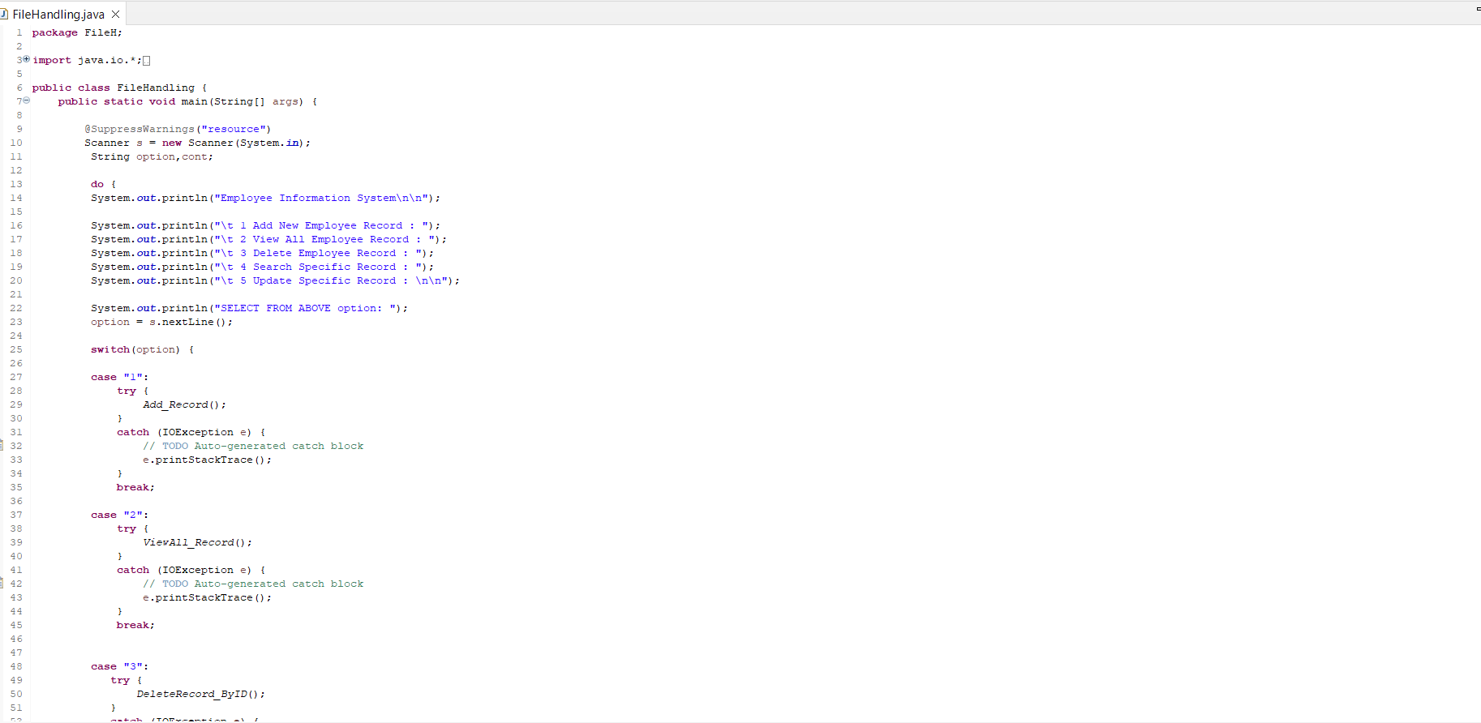

Output Sc shot:

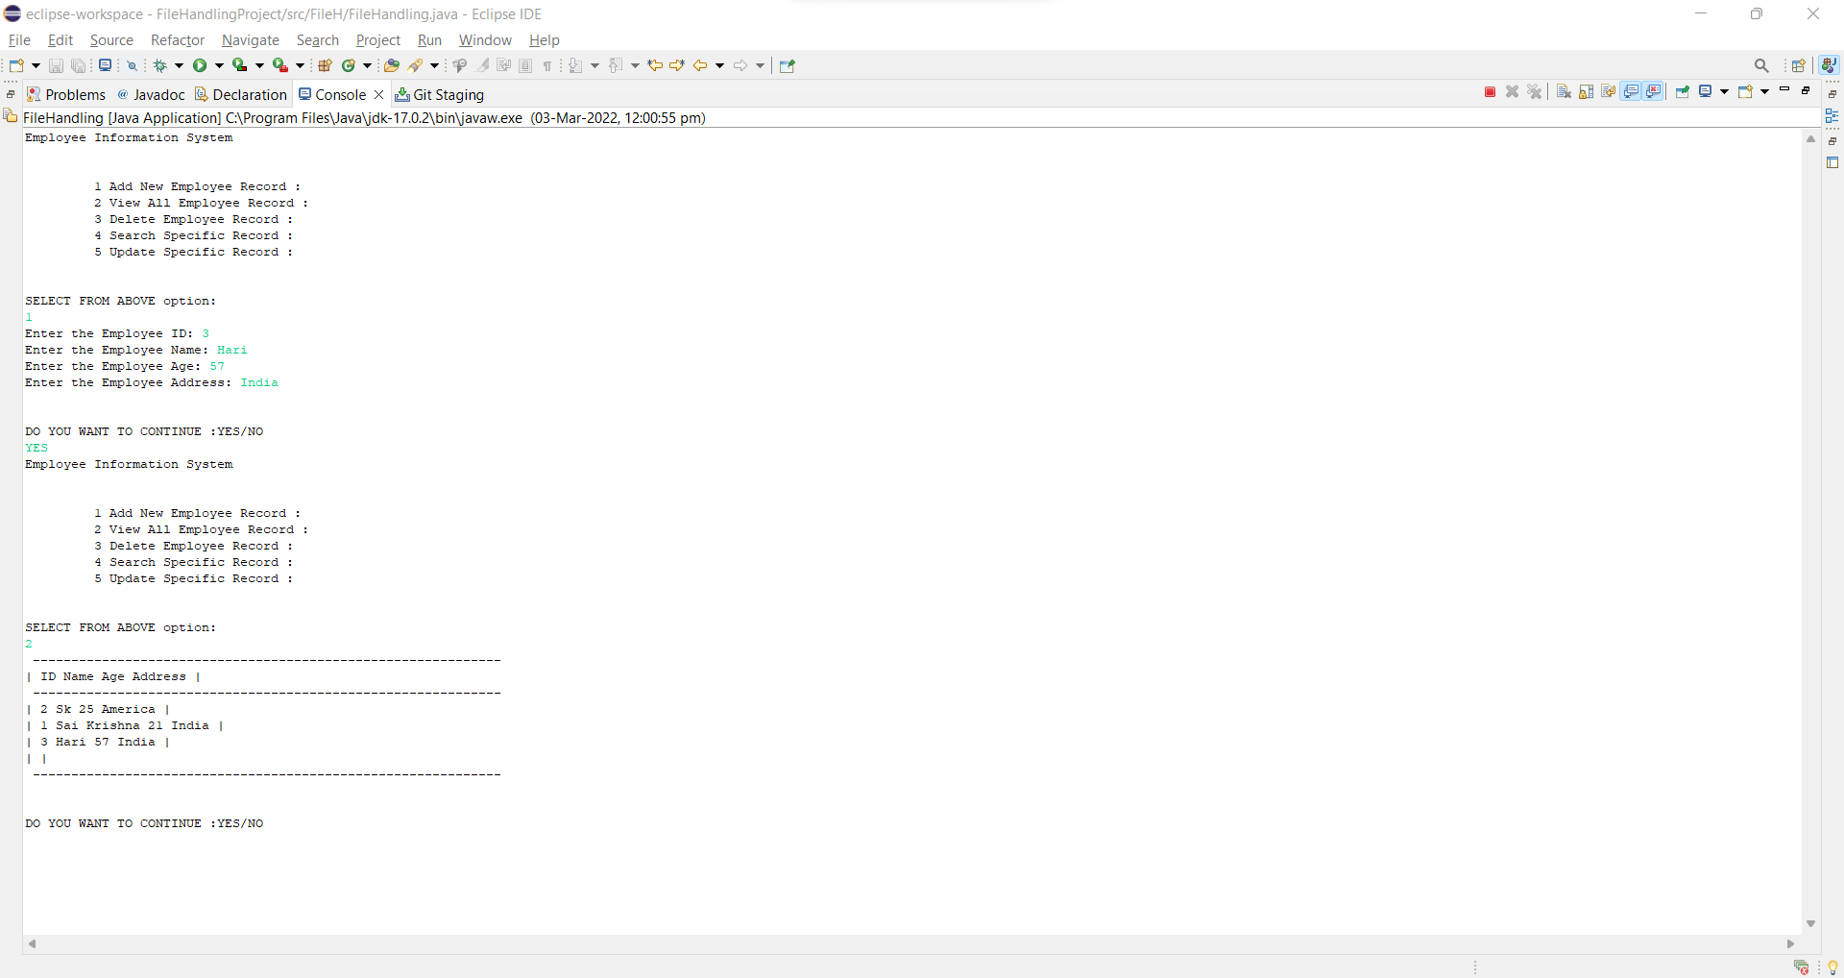

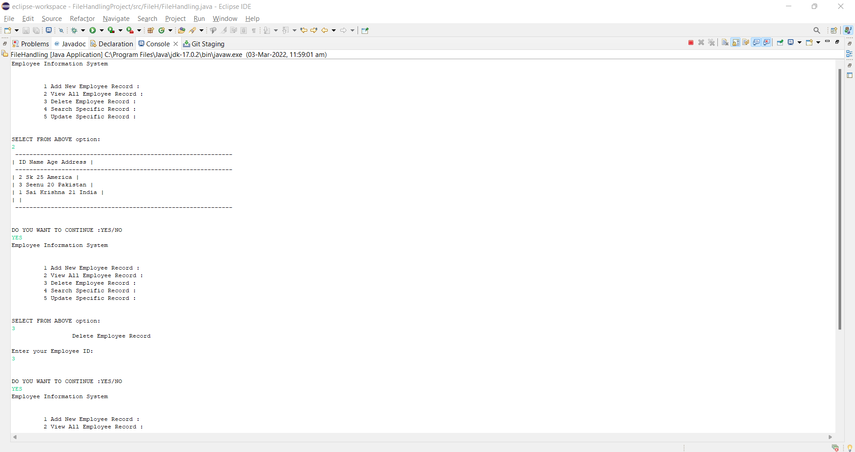

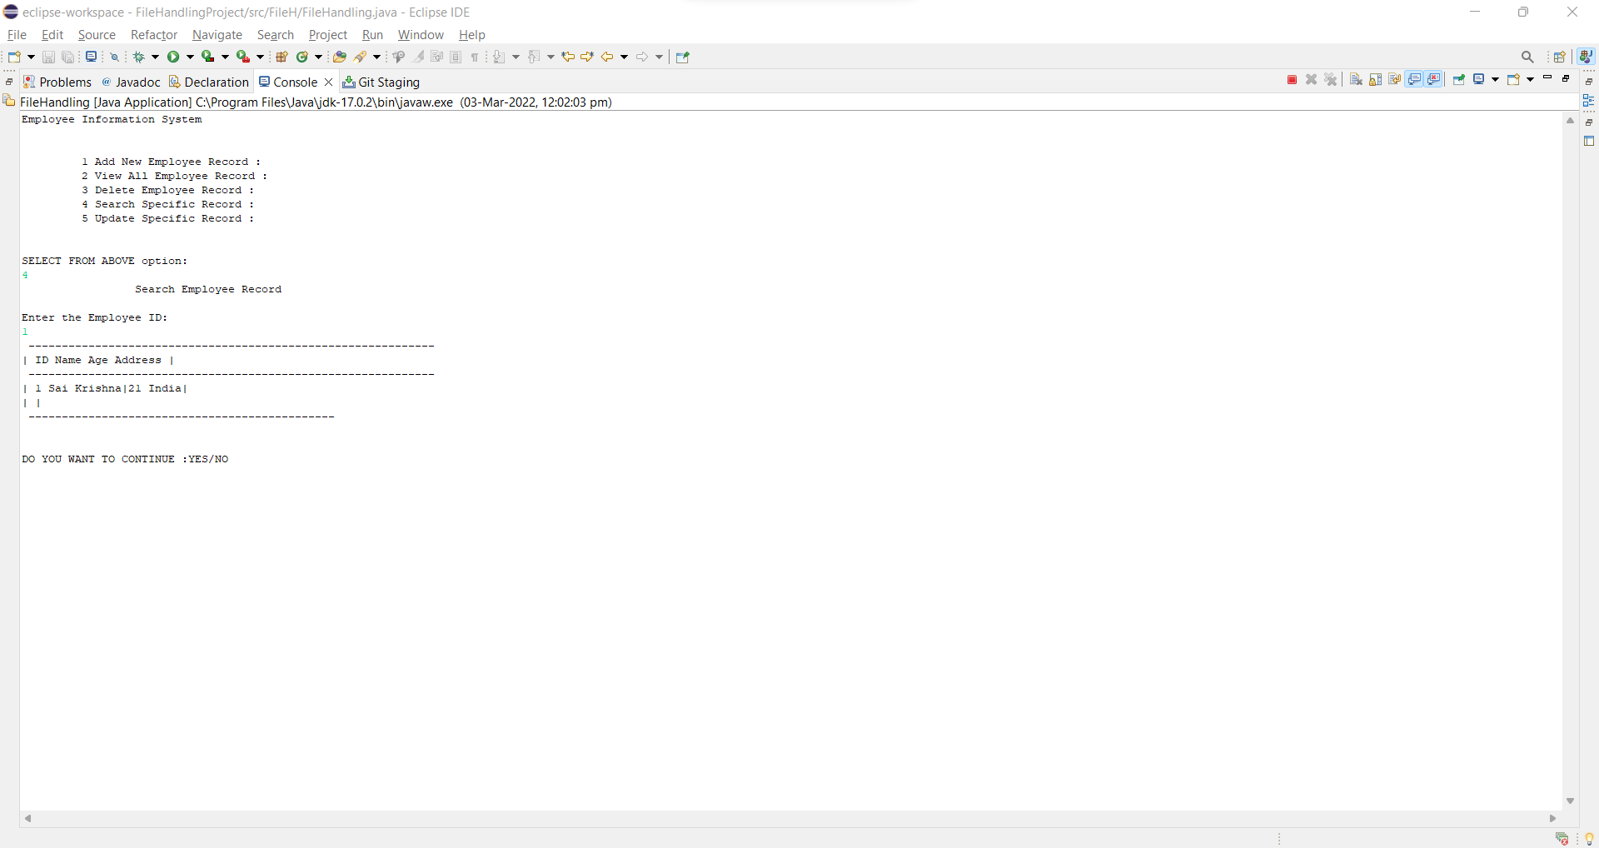

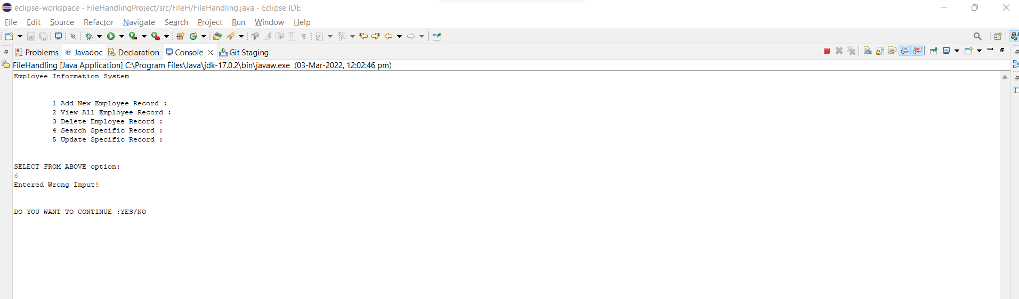

Git Commands:

